akira software solutions pvt ltd.
SMART SAT
User Manual-Version1.0
1/24/2013

This Manual contains the guidelines to the manage the CRM(Customer Relationship Management).The CRM project has done in the codeignetor framework

Index

- Introduction
- Website URL
- Modules Description
- Conclusion

Introduction:
This user manual contains the guidelines to manage the CRM project.There are few modules to which we can manage the contents of the project.Each Module can be easy managed.
The system will be managed using a Super Administrator User, Administrator User and an Agent User. The functionalities of each user types are different.
The super admin in the proposed system has all the privileges by default.
Administrator can add, edit and delete the Customers.
Agents can view all the customer details.
The major functionalities of the Super Admin and Administrator include Uploading the Excel Files which contains the Customer Details.

Website URL:
http://demoweserver.com/administration

To login as Super Admin:

Email id : rajiv@akiraplc.com
Password : 123456

To login as administrator:

Email id : sruthy.hs@akiraplc.com
Password : 123456

To login as Agent:

Email id : thahira.b@akiraplc.com
Password : 123456

Modules Description:
The modules we have are

- Administrators
- Status
- Customers
- Report
- Comments
- Support
- Callback
- Actions
  - Log Out

Notification Box:
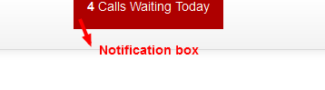
The notification will be shown on the top right of the page after logged in. It shows how many calls pending. The notification is different to each admin users. The Super Admin and Administrator can see all calls pending. But the Agent can see only the pending calls added by him.
Grid Buttons Description:
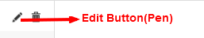
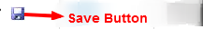
Module Description:
Administrators:
In this module we can manage the Admin users. We can also add a new admin user on clicking Add new admin button and can also choose which type of acces to which the admin user belong to. The Super admin has the privilege to manage admin user management module. The Administrator and Agent are restricted to the Admin user management module.
The pull down placed with the Add new admin button is used to filter the admin users.

Status:
In the module the status can be managed. We can add, edit and delete status such as Active, Cancelled etc. The Super Admin has the only privilege to manage the status module.
Customers:
The customer details are managed here. We can add, edit and delete the customer details. The excel file with customer details can be imported by clicking the Import Excel sheet button. The Add new button is used to add customer. The Super Admin and Administrator have privileges to edit all fields of customers but the Agent can view the customer details and can edit the comments and status fields only.
We can change the status of customers by selecting the status from pull down in the customers listing grid, and click the Save button corresponding to the customer. We can change the status of more than one customer by selecting the status and Click the Save Status button on the top of the grid.
We can add comments to each customer by clicking the comment image place before the customer name. then a pop will be shown and we can add comments by clicking Post comment button in the pop up. The edit and delete of comments are restricted to the Agents. But the agent can view all comments added by Super Admin and also Administrator.
The pop up is Shown below.
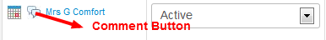
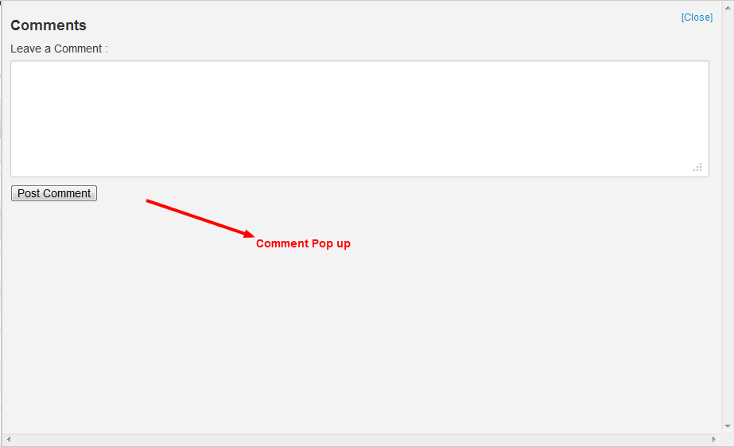
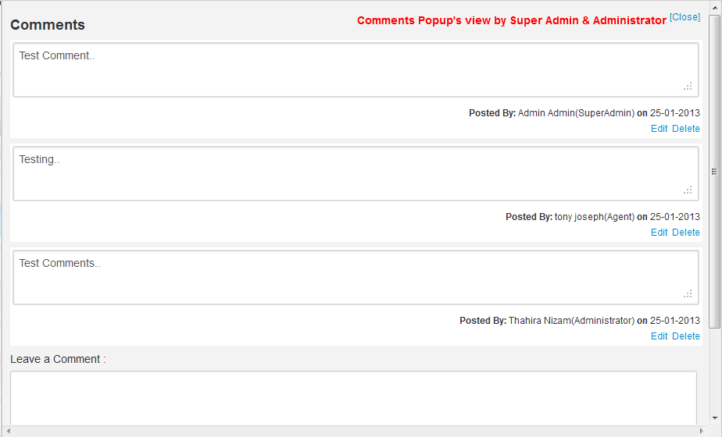
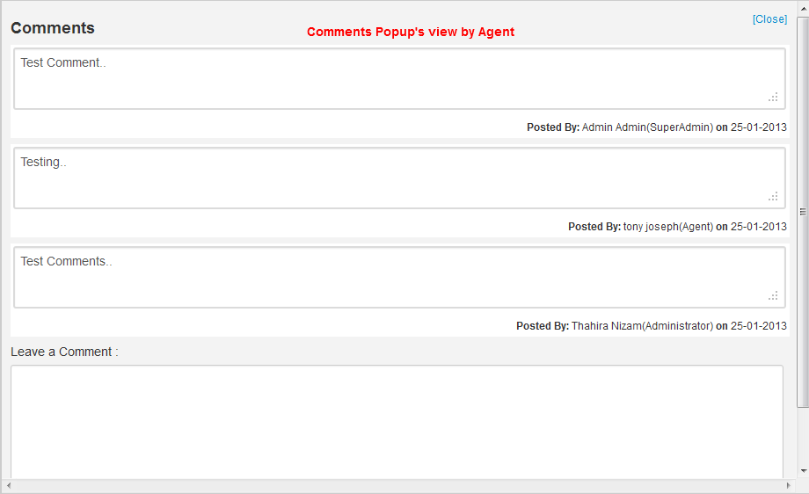

We can assign calls to each customer by clicking the calendar image placed before the customer name. The calls will be notified in the date assigned on the notification box. After calling we can change the call status by clicking the call waiting button, then the status will be changed to DONE. The call management of all customers is restricted to Agent. The Remove button is used to delete the callback details.
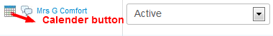
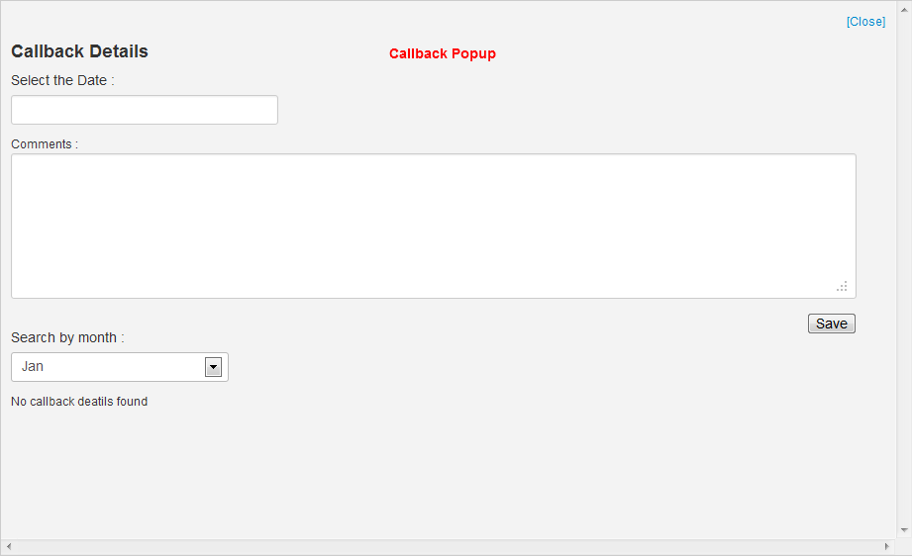
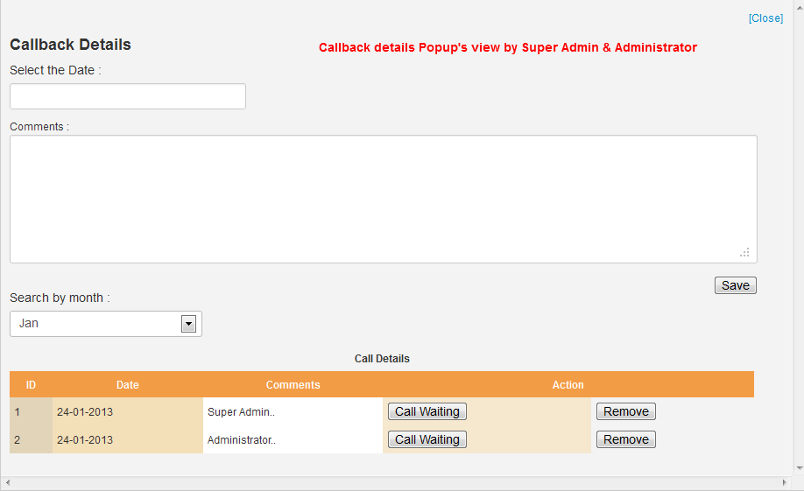
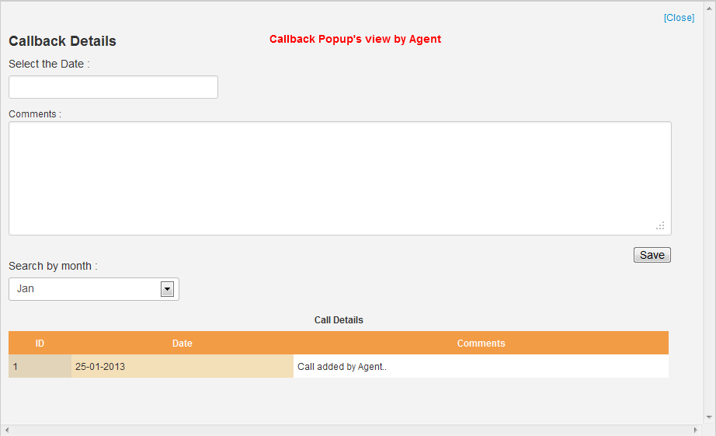

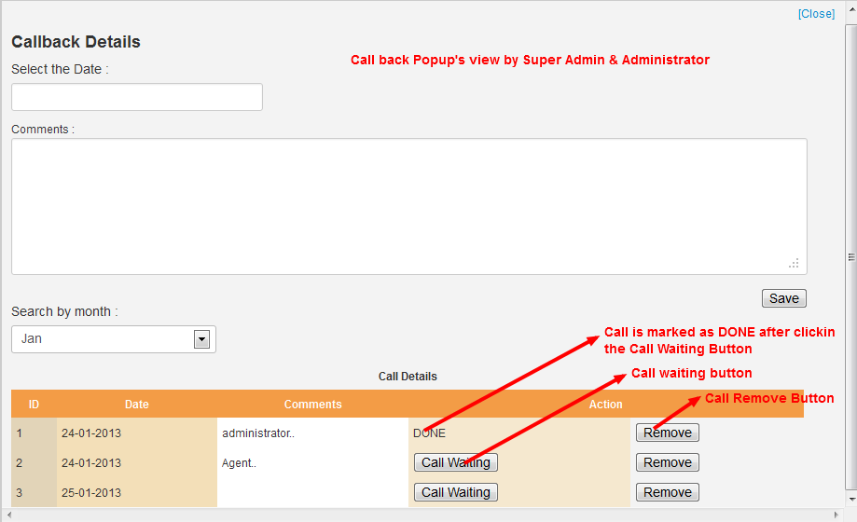

We can generate Report of customers in an excel format with respect to some criteria by Clicking Generate Report button on the top of the grid. The Generate Report form is displayed below.

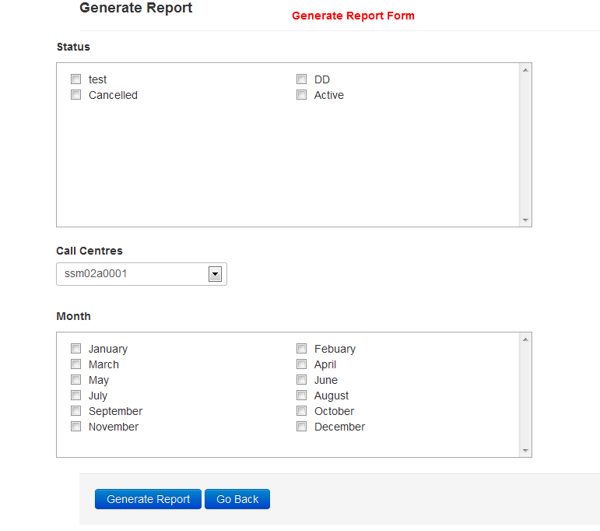
The Go Back button will be redirected to the customers listing page.
Report:
In this module, the pictorial representations of customers are displayed. The Customers deleted in last five months, Customers added in last five months etc. are included.
One type of chart is shown below.
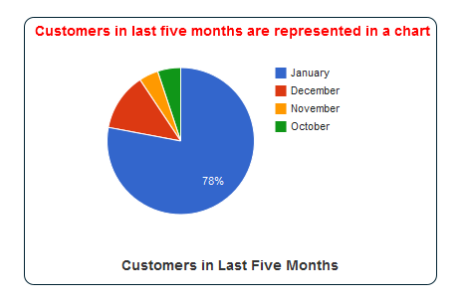

Comments:
In this module, the comments to each customer are displayed here. We can edit and delete the comments. The Super Admin and Administrator can see all comments posted by all admin users. But the Agent can see only the comments posted by all agent users and can have edit and delete the comments posted by him.
Support:
This is belongs to the help desk url.

Callback:
This module deals with the call back details to each customer. The comments to each call details can be edited by clicking the comment image placed with the Customer name. We can delete the call details by clicking the delete button along with each call details.
The Super Admin can edit the comments and delete the whole call details added by all admin users.
The Administrator can edit the comment and delete the whole call details by clicking the notifications box.
The agent can edit the comment and delete the call details added by him by clicking the notification box.

Conclusion:
Thus the user manual for the CRM project has been done and has explained how to manage each and every module in the project.

