PORT MANGEMENT BOARD
Andaman & Nicobar Islands
(Orginal)
Pilotage Certificate

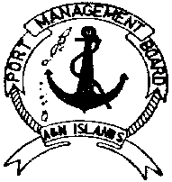
PORT MANGEMENT BOARD
Andaman & Nicobar Islands
(Duplicate)
Pilotage Certificate

No…………………. No………………….
Dated …………… Dated ……………
Proforma for using Tug for Port Operation Proforma for using Tug for Port Operation
- Name of Tug ……………………………… 1. Name of Tug ………………………………
- Duration …………………………………… 2. Duration ……………………………………
- Purpose……………………………………. 3. Purpose…………………………………….
………………………………………………… …………………………………………………
- Observation Period ……………………………. 4. Observation Period …………………………….
- Dated ………………………… 5. Dated …………………………
- Indent No ……………………………………. 6. Indent No …………………………………….
- Indented by ……………………………………….. 7. Indented by ………………………………………..
……………………………………………………………. …………………………………………………………….

Tug Master Tug Master
(Seal) (Seal)
Manager (PS & O) Manager (PS & O)

