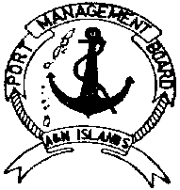
FORM III
PORT MANAGEMENT BOARD
ANDAMAN AND NICOBAR ISLANDS
IMPORT / EXPORT APPLICATION

To
The Port Authority, Date ………………………….
Port of Port Blair Working Place…………….

Per MV ………………………….. Voy No ………………………………… arrived form/ sailing for ………………………… Dated …………….. Shipping Company/ Agent …………………………. …………………..Delivery Order / Shipping Order No ……………………. Dated …………………………………… custom IFR/EF No ………………… Dt ….…………….
Line No | Mark | No.of Pkgs | Description of Cargo | Weight/ Volume | Value of Goods
Certified that the above declaration pertaining to my consignment is correct.
M/s ……………………………………….
Address ………………………………..
……………………………………………….
Signature of Importer/Exporter
With seal/Rubber stamp

For C.R.S. SECTION USE ONLY
Port Charges assessed under notification No GSR (E) dated 01-01-04-1992 and Circular No 5-1/ TR dated 03-07-1991 Rs ………………. (Rupees ………………………………………………………………………………
…………………………………………………......................Only)

RORATION No:

Wharf Superintendent (CRS)

